Wind LCOE

David Leitch

2024-07-28

# Wind LCOE have risen despite flattish turbine prices

Compared to the absolute low in 2018 turbine prices are up about 25% in AUD based on reported Vestas data and in fact about the same using a 3 year rolling average.

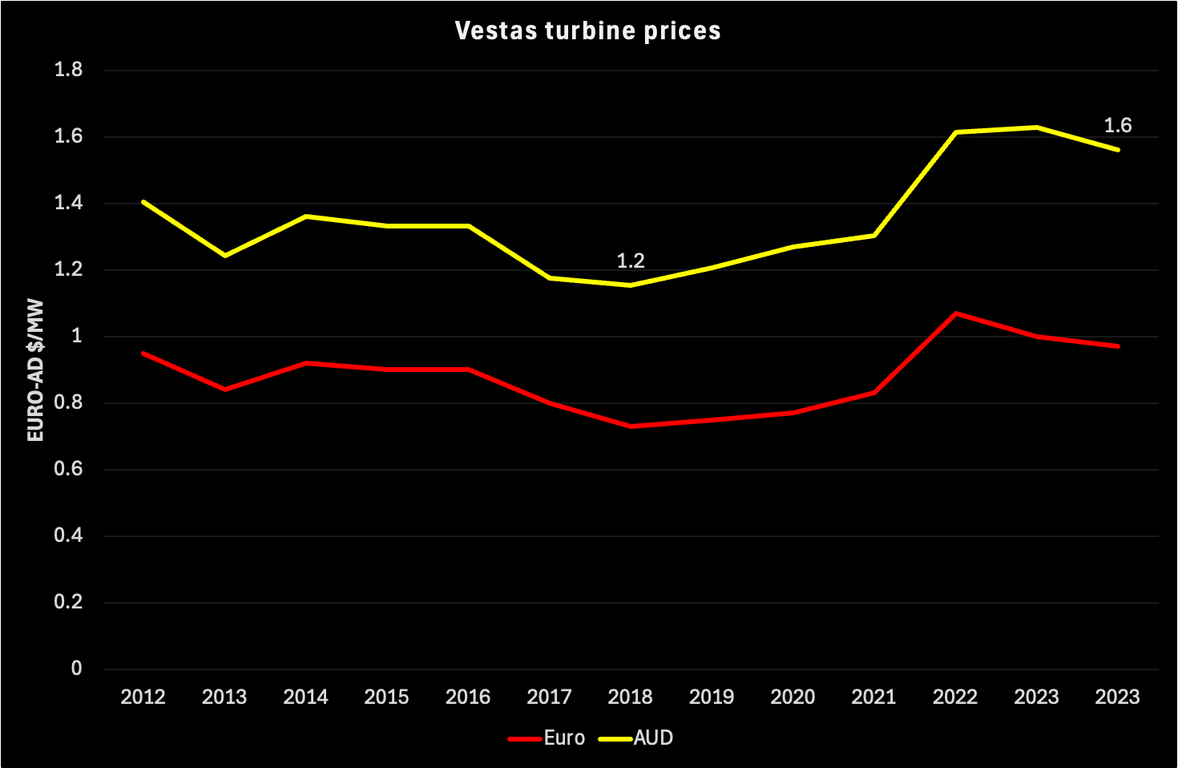

image-20240715120056175

On the other hand some major wind farm relatively big PPAs were written at A$50/MWh whereas today a well founded, if pessimistic view might see LCOE at closer to A$1000 than A$90/MWh. Something like 100% rise.

This increase has come despite the fact that since 2018 turbine size have risen from something like 4 MW to something like 6 MW meaning that fewer turbines are needed for a given wind farm. The increase in size should have driven cost down but it hasn’t, at best its limited the cost increase.

Data on costs is hard to come by. However Engie developer of the “Hills of Gold Windfarm” near Nundle submitted some fairly detailed LCOE data in support of a view that it could not cut turbines from its project and have it remain viable. An independent expert advisory report provided to the Department of Planning, Housing and Infrastructure itself issued a document commenting on Engie’s numbers.

By way of background Hills of Gold (HOG) has been in EIS exhibition stage since early 2021. Over the course of three years the number of turbines reduced from 97 to 70 and then to 64. The Department then asked for a further 17 turbines to be removed but Engie has agreed to only 2 leaving Engie’s proposal for 62 nominal 6 MW turbines with a nominal capacity of 372 MW.

Although not directly the subject of this note the Department basically wanted turbines removed because of visual, noise and biodiversity issues. Just in regard to noise, turbines generally produce sound in the range of 35-45 dB at a range of 300 metres. 45 dB is not a lot of noise, a modern air conditioner produces say 85 dB (its a log scale), a fridge is 50 dB. Anyhow…..

## Wind LCOE drivers

Please note that LCOE stands for Levelised Cost of Energy and the output is the average price per MWh produced and sold over the projects life required to justify the investment. Note that price is not just the electricity price but in Australia REC revenues, while they exist, reduce the price recquired in the wholesale market. Put in the language of finance its the average price that produces a Net Present Value (NPV) of zero. In the language of micro economics, something the Economics Editor of the AFR clearly has no clue about, its the Long Run Marginal Cost (LRMC).

Not many inputs are required to estimate a wind farm LCOE, the input buckets are:

* Capital cost;
* Capacity factor, with the wrinkle that in Australia we have to, at present, allow for the Marginal Loss Factor (MLF);
* Operating cost;
* End of life Disposal cost. For oil and gas projects this is an increasingly big deal but for wind and solar farms its often ignored on the basis the project will be repowered.
* The discount rate or weighted average cost of capital (WACC). There is no correct answer to a discount rate, in the end it’s a matter of opinion, but there is a clear theory of how to calculate it. The opinion comes around estimating the non diversifiable risk of the project, the so called and unobservable asset beta. For unlisted wind and solar farms there are not really any benchmarks in Australia to even provide a guide.

### Capital cost

Even capital cost is an elusive concept. That’s because these days the fixed capital cost of getting a project to the grid is typically variabilised into an annual payment, ie more or less a lease. Theoretically I guess this reflects a judgement that the transmission company has a higher debt rating and therefore a lower interest cost than the wind farm developer. So it’s cheaper to borrow from the transmission company via a lease payment than stretch the developer’s bank account.